**A Real-time Research Project Report on**

**ONLINE LIBRARYMANAGEMENT SYSTEM(E-BOOKS)**

A Dissertation submitted to JNTU Hyderabad in partial fulfillment of the academic requirements for the award of the degree.

**Bachelor of Technology**

**In**

**COMPUTER SCIENCE AND ENGINEERING**

Submitted by

D.VINAY

(22H51A0578)

G.SRIKAR

(22H51A0582)

G.SOWMYA

(22H51A0588)

Under the esteemed guidance of

Mr.P.Senthil

(Asst.Professor)



**Department of Computer Science and Engineering**

### CMR COLLEGE OF ENGINEERING & TECHNOLOGY

(UGC Autonomous)

*Approved by AICTE *Affiliated to JNTUH *NAAC Accredited with A+ Grade

KANDLAKOYA, MEDCHAL ROAD, HYDERABAD - 501401.

### 2023- 2024

**CMR COLLEGE OF ENGINEERING & TECHNOLOGY**

KANDLAKOYA, MEDCHAL ROAD, HYDERABAD – 501401

**DEPARTMENT OF COMPUTER SCIENCE AND ENGINEERING**



### CERTIFICATE

## This is to certify that the Real-time Research Project report entitled

## " ONLINE LIBRARY MANAGEMENT SYSTEM (E-BOOKS)" being submitted by D.VINAY (22H51A0578), G.SRIKAR (22H51A0582), G.SOWMYA (22H51A0588) in partial fulfillment for the award of Bachelor of Technology in COMPUTER SCIENCE AND ENGINEERING

## is a record of bonafide work carried out under my guidance and supervision.

## The results embodies in this project report have not been submitted to any other University or Institute for the award of any Degree.

**Mr.P.Senthil**

**Asst. Professor Dr. S. Siva Skandha**

**Dept. Of CSE HOD CSE**

### ACKNOWLEDGEMENT

With great pleasure we want to take this opportunity to express our heartfelt gratitude to all the people who helped in making this project a grand success.

We are grateful to **Mr.P.Senthil,** **Asst. Professor**, Department of Computer Science and Engineering for his valuable technical suggestions and guidance during the execution of this project work.

We would like to thank**, Dr. S. Siva Skandha,** Head of the Department of Dept Computer Science and Engineering, CMR College of Engineering and Technology, who is the major driving forces to complete our project work successfully.

We are very grateful to **Dr. Ghanta Devadasu**, Dean-Academics, CMR College of Engineering and Technology, for his constant support and motivation in carrying out the project work successfully.

We are highly indebted to **Major Dr. V A Narayana,** Principal, CMR College of Engineering and Technology, for giving permission to carry out this project in a successful and fruitful way.

We would like to thank the **Teaching & Non- teaching** staff of Department of Dept Name for their co-operation

We express our sincere thanks to **Shri. Ch. Gopal Reddy**, Secretary& Correspondent, CMR Group of Institutions, and Shri Ch Abhinav Reddy, CEO, CMR Group of Institutions for their continuous care and support.

Finally, we extend thanks to our parents who stood behind us at different stages of this Project. We sincerely acknowledge and thank all those who gave support directly or indirectly in completion of this project work.

D.VINAY 22H51A0578

G.SRIKAR 22H51A0582

G.SOWMYA 22H51A0588

**TABLE OF CONTENTS**

|  |  |
| --- | --- |
| **CHAPTER NO. TITLE** | **PAGE NO.** |
| LIST OF FIGURES | ii |
| LIST OF TABLES | iii |
| ABSTRACT | iv |
| **1 INTRODUCTION** | 1 |
| 1.1 Problem Statement | 2 |
| 1.2 Research Objective | 2 |
| 1.3 Project Scope and Limitations | 3 |
| **2 BACKGROUND WORK** | 4 |
| 2.1. **Manual Record-Keeping System** |  |
| 2.1.1.Introduction | 5 |
| 2.1.2.Merits,Demerits and Challenges | 5 |
| 2.1.3.Implementation | 5 |
| 2.2.  **Standalone Computer-Based System** |  |
| 2.2.1.Introduction | 6 |
| 2.2.2.Merits,Demerits and Challenges | 6 |
| 2.2.3.Implementation | 6 |
| **3 PROPOSED SYSTEM** | **7** |
| 3.1. Objective of Proposed Model | 8 |
| 3.2. Algorithms Used for Proposed Model | 9 |
| 3.3. Designing | 10 |
| 3.3.1.UML Diagram | 10 |
| 3.3. Stepwise Implementation and Code | 12 |
| **4 RESULTS AND DISCUSSION** | 13 |
| 4.1. Performance metrics | 14 |
| **5 CONCLUSION** | 15 |
| 5.1 Conclusion and Future Enhancement | 16 |
| **REFERENCES** | 18 |

**List of Figures**

|  |  |  |
| --- | --- | --- |
| **FIGURE NO.** | **TITLE** | **PAGE NO.** |
| 3.2.1 | Flow chart | 9 |
| 3.3.1 | UML Diagram | 10 |
| 3.3.2.1 | Implementation | 11 |
| 3.3.2.2 | Registration Page | 11 |
|  |  |  |

**List of Tables**

**TABLE NO. TITLE PAGE NO.**

4.1 Performance Metrices . 14

# ABSTRACT

The "Online Library Management System (E-books)" project is designed to create a userfriendly and comprehensive platform for browsing, purchasing, and managing electronic books. Users can effortlessly register on the platform, allowing them to securely log in and access a vast catalog of e-books categorized by genre, author, and other criteria. The advanced search functionality enables users to find books quickly, check their availability in the store online, and each book's detailed page provides descriptions, author information, and user reviews. The system ensures a seamless purchasing experience with a secure shopping cart and reliable payment gateways that support various payment methods. Upon completing a purchase, users can instantly download their e-books in multiple formats compatible with different e-readers. The admin panel empowers administrators to efficiently manage library resources, user accounts, and transactions, ensuring the system runs smoothly. Designed for high performance, scalability, and robust security, the platform also includes future-ready features like personalized book recommendations and social interaction capabilities, providing a comprehensive solution for modern digital library needs.

# CHAPTER 1

## INTRODUCTION

**CHAPTER 1**

**INTRODUCTION**

**1.1.Problem Statement**

In today's digital age, traditional library systems face significant challenges in managing and distributing e-books efficiently. The current methods of cataloging, storing, and providing access to digital books are often fragmented, leading to difficulties in book retrieval, inconsistent user experiences, and inefficiencies in library operations. Users face obstacles in finding and borrowing e-books seamlessly, and libraries struggle to integrate digital rights management effectively. Additionally, the lack of a unified platform that supports multi-device access and personalized recommendations hinders user engagement and satisfaction. To address these issues, there is a pressing need for a robust Online Library Management System specifically tailored for e-books. This system should offer comprehensive features for streamlined book management, secure distribution, and enhanced user accessibility, ensuring an efficient, user-friendly, and technologically advanced solution for modern library needs.

**1.2.Research Objective**

This applied research aims to design, develop and implement online library management system.

This web-based application provides:

• **Analyze Existing Systems**: Identify and address the limitations and inefficiencies of current library management systems in handling e-books.

• **Develop a Comprehensive Platform**: Design a user-friendly system with features for user registration, book borrowing, returning, and advanced search functionality.

• **Ensure Secure Access**: Integrate robust digital rights management (DRM) solutions to protect and securely distribute e-books.

• **Enhance User Experience**: Implement personalized recommendations and multi-device access for a consistent and engaging user experience.

• **Improve Operational Efficiency**: Streamline cataloging, storing, and retrieving processes to optimize library operations and scalability.

#### Project Scope and Limitations

##### Scope:

* **User Management**: Implementing features for user registration, authentication, and profile management.
* **E-Book Cataloging**: Developing a comprehensive database for cataloging e-books with metadata like author, genre, publication date, and more.
* **Multi-Device Access**: Ensuring the platform is accessible across various devices such as smartphones, tablets, and computers.
* **User Interface Design**: Creating an intuitive and user-friendly interface for both users and library administrators.
* **Scalability and Integration**: Ensuring the system can scale to accommodate a growing number of e-books and users, and integrate with existing library systems.
* **Search and Retrieval**: Providing advanced search functionalities to allow users to easily find and access e-books.

##### Limitations:

* **Digital Rights Management (DRM) Constraints**: Implementing DRM may restrict certain functionalities, such as sharing, copying, or printing e-books, potentially affecting user experience.
* **Device Compatibility**: Ensuring compatibility across all devices and operating systems can be challenging, and some older devices may not fully support the platform.
* **User Adoption and Training**: The system’s success relies on user adoption, which may require comprehensive training and continuous support to ensure users are comfortable and proficient with the platform.
* • **Network Dependency**: As an online platform, the system requires a stable internet connection, which may limit accessibility in areas with poor or unreliable internet service.
* • **Initial Setup and Maintenance Costs**: Developing, deploying, and maintaining the system may involve significant initial costs and ongoing expenses for updates, support, and system enhancements.

# CHAPTER 2

## BACKGROUND WORK

1. **Existing Methods:**

### CHAPTER 2 BACKGROUND WORK

##### Method 1: Manual Record-Keeping System

* + 1. **Introduction**
       - Manual record-keeping involves maintaining physical logs and paperwork to track blood donations, inventories, and recipient information.

##### Merits, Demerits, and Challenges Merits:

* + - * **Low Initial Cost:** Requires minimal investment in technology and infrastructure.
      * **Simplicity:** Easy to understand and use for staff with basic training.

##### Demerits:

* + - * **Error-Prone:** High risk of human errors in data entry and record management.
      * **Inefficiency:** Time-consuming and labor-intensive, leading to slow processes.

##### Challenges:

* + - * **Data Security:** Physical records are vulnerable to loss, theft, or damage.
      * **Scalability:** Difficult to manage as the volume of records increases.

##### Implementation

* + - * **Setup Physical Logs:** Purchase and organize physical logbooks, folders, and filing cabinets.
      * **Define Procedures:** Develop standardized forms and procedures for data entry and record-keeping.
      * **Staff Training:** Train staff on proper data entry techniques, record management, and retrieval processes.
      * **Maintenance:** Regularly audit and maintain records to ensure accuracy and completeness.

##### Method 2: Standalone Computer-Based System

* + 1. **Introduction:**
       - Standalone computer-based systems use software installed on individual computers to manage blood bank operations without network connectivity.

##### Merits, Demerits, and Challenges Merits:

* + - * **Improved Accuracy:** Reduces human error through digital record-keeping.
      * **Faster Processing:** Speeds up data retrieval and management compared to manual methods.

##### Demerits:

* + - * **Limited Access:** Data is confined to specific computers, hindering accessibility.
      * **Data Synchronization:** Difficult to synchronize data across multiple locations or users.

##### Challenges:

* + - * **Backup and Recovery:** Risk of data loss if the system crashes without proper backup.
      * **Maintenance:** Requires regular updates and maintenance of software on individual machines.

##### Implementation

* + - * **Software Selection:** Choose appropriate blood bank management software for standalone computers.
      * **Installation:** Install the software on designated computers within the blood bank.
      * **Data Migration:** Transfer existing records into the digital system.
      * **User Training:** Train staff on using the software for data entry, management, and retrieval.
      * **Regular Updates:** Schedule regular software updates and maintenance checks.

# CHAPTER 3

## PROPOSED SYSTEM

### CHAPTER 3 PROPOSED SYSTEM

#### Objective of Proposed Model

The objective of the proposed web-based Blood Bank Management System is to create an efficient, user-friendly platform that streamlines the management of blood donations, inventory, and distribution. This system aims to enhance operational efficiency, improve user experience, ensure data accuracy, and maintain robust security.

**Enhancing User Experience**

The system offers an intuitive, responsive interface for donors, recipients, and staff. Donors can register, schedule appointments, and track their history seamlessly. Recipients can easily request blood, and staff can manage information and interactions efficiently, improving the overall workflow.

**Streamlining Inventory Management**

Real-time inventory management tracks blood collection, storage, and distribution, ensuring optimal levels and reducing waste through automated alerts for low stock or expiring units. This ensures timely and efficient management of blood supplies.

**Ensuring Data Accuracy and Security**

Robust security measures, including encryption, multi-factor authentication, and role-based access, protect sensitive data. Compliance with health regulations and data protection standards ensures the safety of donor and recipient information, with detailed audit logs for accountability.

**Facilitating Efficient Communication**

Automated notifications and reminders via email, SMS, and in-app messaging enhance engagement and responsiveness, ensuring timely donation appointments and urgent blood request alerts.

#### Algorithms/Flow chart Used for Proposed Model

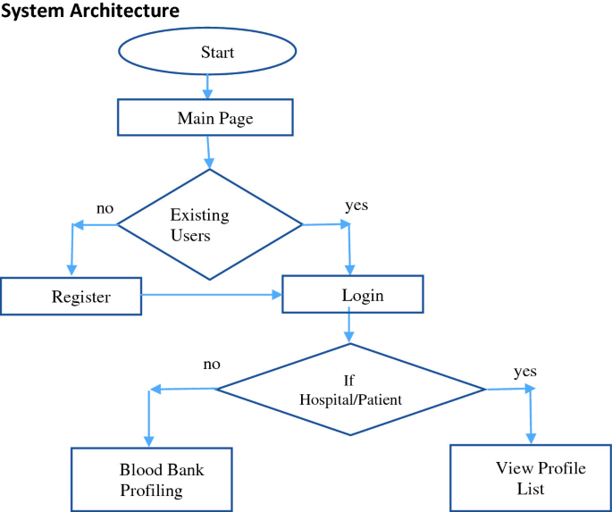

Fig 3.2 Flow Chart

#### Designing

* + 1. **UML Diagram**

Fig :3.3.1 UML Diagram

#### 3.3.2 Stepwise Implementation and Code

Fig 3.3.2.1 Home page

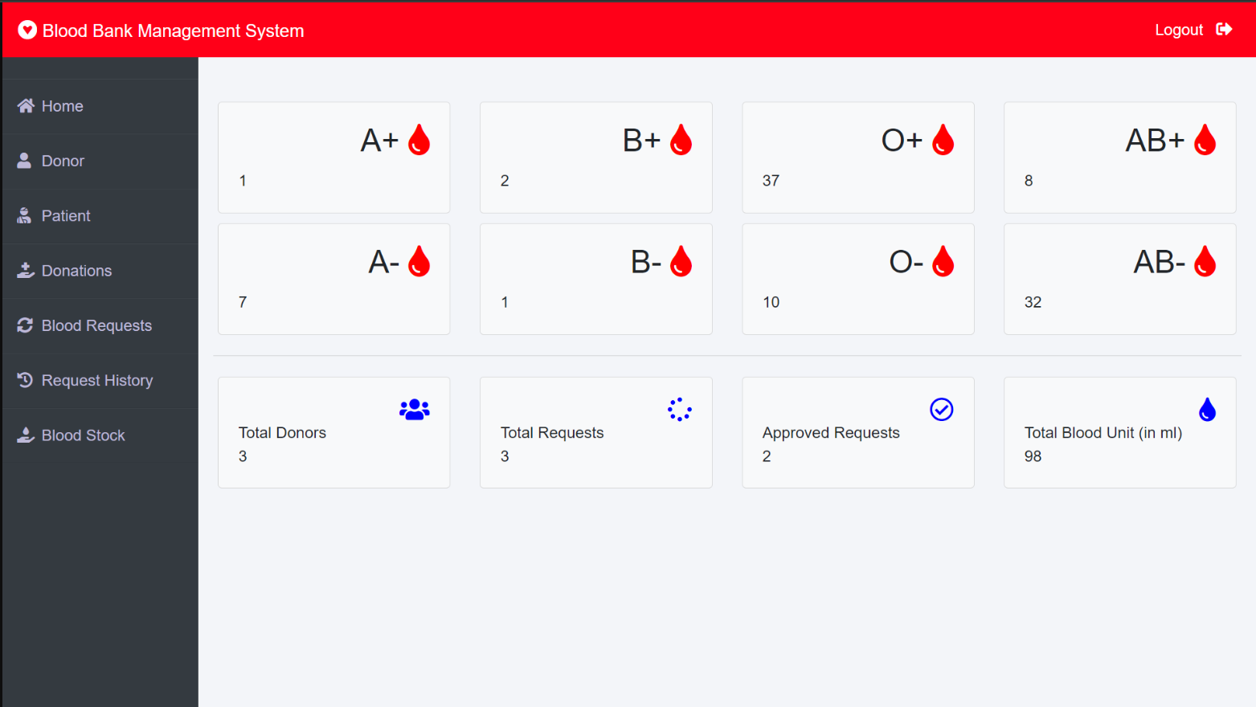

Fig 3.3.2.2 Admin dashboard

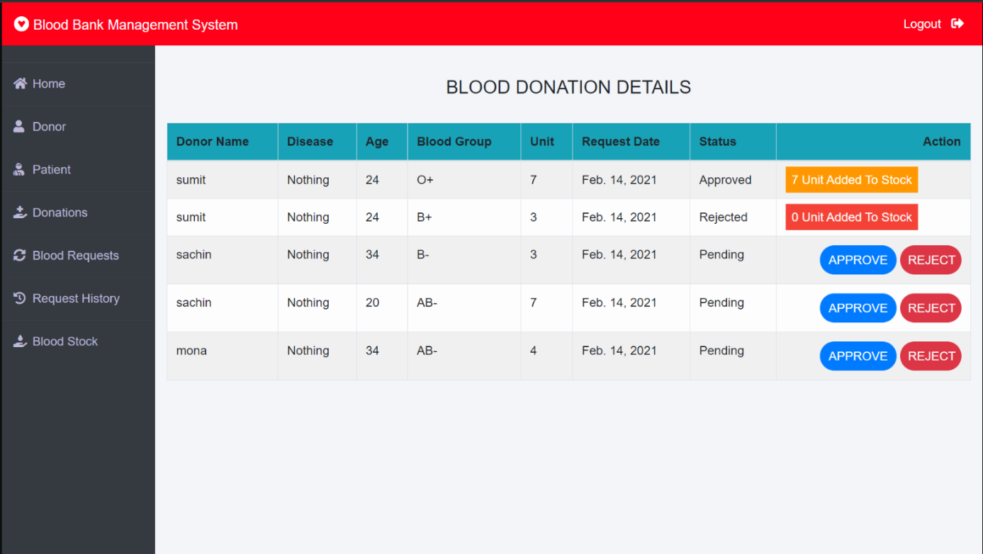

Fig 3.3.2.3 Blood donation details

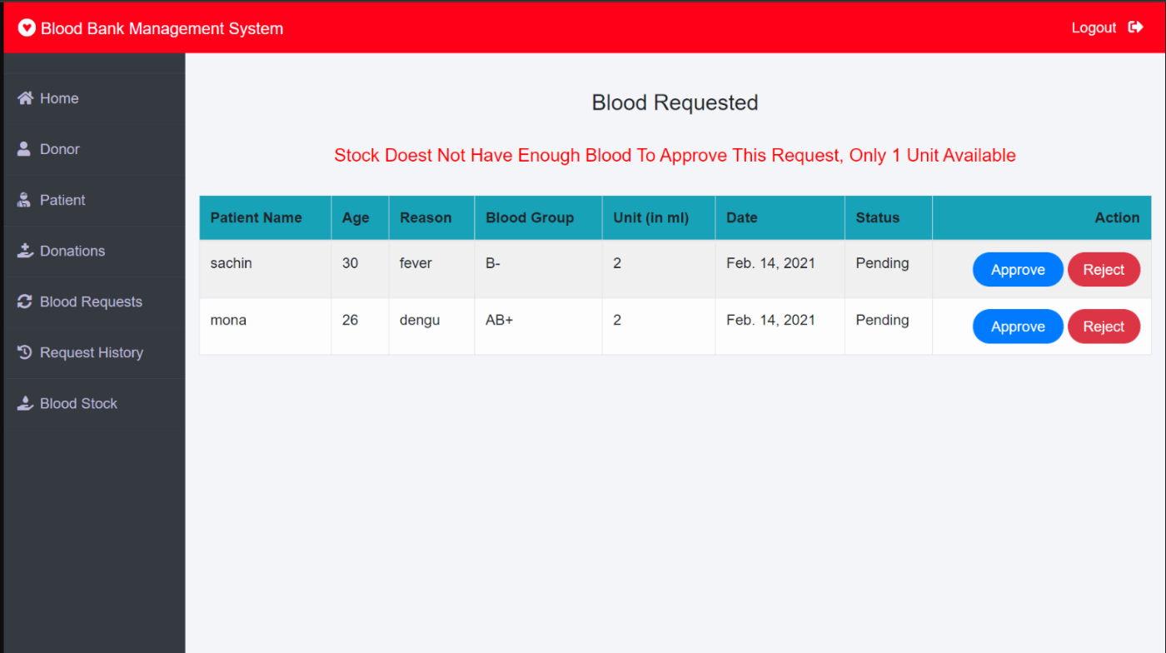

Fig 3.3.2.4 Blood Requested

# CHAPTER 4

## RESULTS AND DISCUSSION

BLOOD BANK MANAGEMENT SYSTEM

### CHAPTER 4 RESULTS AND DISCUSSION

#### 4.1. Performance metrics

|  |  |
| --- | --- |
| **Performance Metric** | **Description** |
| 1. **Blood Stock**   **Management** | - **Stock Levels:** Accuracy of blood inventory levels (number of units available for each blood type). |
|  | - **Turnover Rate:** Frequency of blood units being added and utilized (per day/week) |
|  | - **Expiry Management:** Reduction in expired blood units due to efficient stock rotation and utilization. |
| 1. **Donation Process**   **Efficiency** | - **Approval Time:** Average time taken to approve or reject a blood donation request. |
|  | - **Donation Processing Time:** Time taken from donor registration to the addition of blood units to the stock. |
|  | - **Rejection Rate:** Percentage of donation requests rejected and reasons for rejection. |
| 1. **Blood Request**   **Fulfillment** | - **Request Approval Time:** Average time taken to approve or reject a blood request. |
|  | - **Fulfillment Rate:** Percentage of approved blood requests fulfilled from available stock. |
| 1. **Environmental**   **Impact** | - **Waste Reduction:** Reduction in expired or unused blood units. |
|  | **- Resource Utilization:** Efficiency in using resources like storage facilities and medical supplies. |
| 1. **User**   **Experience** | - **Satisfaction Ratings:** User feedback on ease of use, navigation, and overall satisfaction. |
|  | - **Convenience Factors:** Ease of registration, request submission, and tracking status for donors and patients. |
| 1. **Safety and Security** | - **Data Security:** Measures in place to protect donor and patient information. |
|  | - **Compliance:** Adherence to healthcare regulations and standards. |
| 1. **Operational Efficiency** | - **System Uptime:** Availability and reliability of the blood bank management system. |
|  | - **Response Time:** Timeliness of addressing technical issues or system downtime. |
|  | - **Operational Costs:** Cost-effectiveness of maintaining and operating the system. |

CHAPTER 5

## CONCLUSION

### CHAPTER 5 CONCLUSION

#### 5.1 Conclusion and Future Enhancement

In conclusion, the proposed web-based Blood Bank Management System offers a comprehensive solution to streamline blood donation, inventory management, and distribution processes. By enhancing user experience with an intuitive interface, ensuring data accuracy through robust security measures, and facilitating efficient communication and reporting, the system aims to significantly improve operational efficiency and healthcare outcomes.

**Future Enhancements**

Looking ahead, several enhancements could further optimize the system:

1. Integration with IoT Devices: Im plementing IoT sensors for real-time monitoring of blood storage conditions to ensure quality and safety.

2. Machine Learning for Prediction: Utilizing machine learning algorithms to predict blood demand based on historical data and seasonal trends, optimizing inventory levels.

3.Blockchain for Transparency: Incorporating blockchain technology to enhance transparency and traceability of blood donations from donor to recipient.

4. Mobile App Development: Developing a mobile application for donors and recipients to schedule appointments, receive notifications, and access their records on-the-go.

5. Expanded Analytics Capabilities: Enhancing analytics tools to provide deeper insights into donor demographics, donation patterns, and recipient needs for more informed decision-making.

## REFERENCES

### REFERENCES

<https://www.slideshare.net/slideshow/blood-bank-management-system-including-uml-diagrams/33680362>

<https://www.scribd.com/document/406805940/Blood-Bank-Management-System-docx>

<https://bsssbhopal.edu.in/uploads/naac/criteria_1/students_projects/272%20Simran.pdf>